Community Health Investigative Report:
A Project
Empowering Nurses

A Student-Led Conference

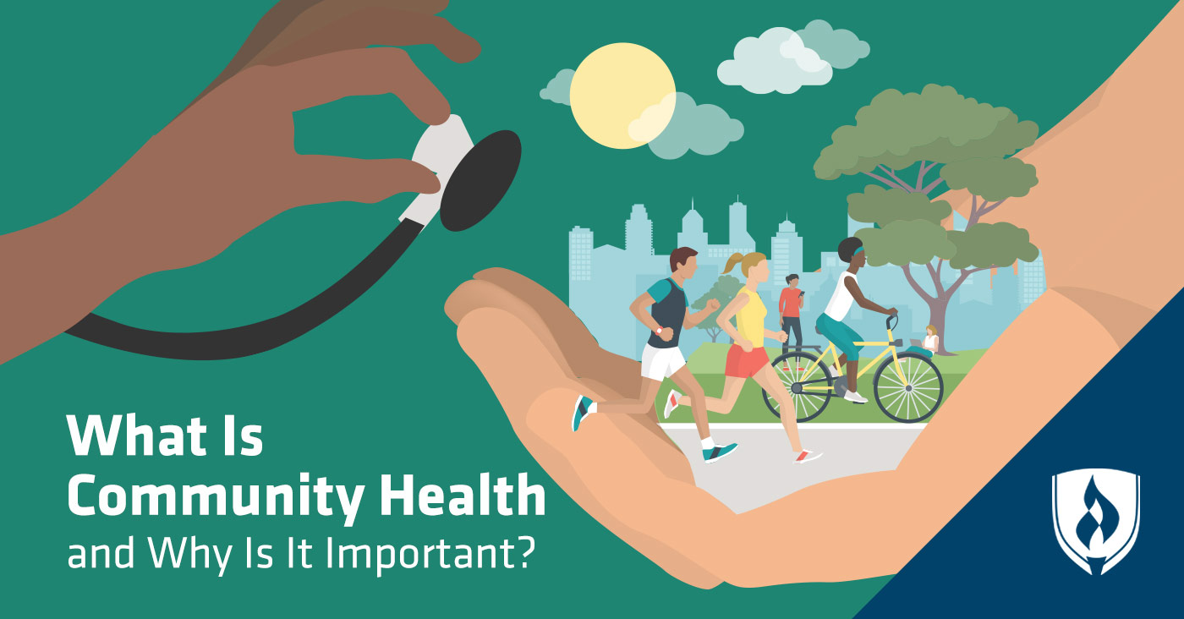
(Image credit: Ramussen College)

Using the Nursing Process in Community Health Settings

A Community Assessment, Health Promotion, Action Planning Assignment

Community Health Investigative Report Project

Small Group Assignment Guidelines

Outcome:

Upon completion of the Community Health Project, the student will be able to identify, research and evaluate public health needs in a community; define nursing roles in the community; and propose ways to improve health leading to positive changes in the local community's health.

Purposes:
- Provide an opportunity to research, assess, and use professional nursing communication skills to recommend ways to implement health promotion and disease prevention ideas leading to positive changes in the local community's health.
- Help students further develop their critical thinking and clinical judgment skills through assessment, planning, and professional communication.
- Prepare students for the professional working environment where teamwork is an expectation.
- Encourage nursing student involvement within their communities.
- Participate as a group member in the development, delivery, and evaluation of a professional presentation addressing community health needs.
- Empower students to recognize opportunities and propose positive changes to improve a community’s health.
- Gain a deeper understanding of nursing roles in public health and the local community.
Learning Objectives:
- Assess how the needs of a targeted health issue within a local community are being addressed through the lens of public health.
- Utilize professional nursing and/or healthcare journals, as well as online and library resources, to investigate current, evidence-based healthcare practices.
- Research how to improve the well-being and health of the community.
- Create a professional presentation, directed towards colleagues, interested community members and leaders, that will include:
  - A variety of professional communication methods (for example: reading, visual, listening and hands-on),
  - Realistic ideas for collaboration, and
  - An investigation of the cost-effectiveness of the purposed interventions or improvements.
- Propose ways that community health leaders can promote health, wellness and improve services provided to the target population.
- Evaluate the effectiveness of the Community Health Investigation and presentation.
- Evaluate the level of participation of teammates in the development, implementation, and evaluation of the Community Health Investigation Report Project.

Instructions for Small Group Assignment

This is a group project for which you will receive a group grade. The grade will be determined using the Community Health Investigative Report Project (CHIRP) Rubric.

(Image credit: Getty Images)

Group Organization
- Faculty will place students into groups based on students’ interests indicated on the CHIRP 2022 google form.
- Group functioning is the responsibility of the group, including leadership and problem solving.
- Faculty advisors should be notified if there are any unresolved issues.
- The Community Health Investigative Report Presentation (CHIRP) is expected to reflect your group’s work. This is NOT an individual assignment.

Each group will research their community health issue, turn in a portfolio, and give a 60-minute presentation.

Presentations will include:
- An overview of the topic, nursing roles (video, PowerPoint presentation, use of other presentation media, etc.)
- Interviews and Windshield Survey for community assessment and better understanding of the needs of:
  - persons affected,
  - nurses working in the area, and
  - community advocates and stakeholders
- A tri-fold poster highlighting the topic, resources, and health improvement action plan ideas (including short- and long-term goals for the community)

Community Health Investigative Report Introduction Class

*Each Individual Student

- Using data available on the Deschutes County website, determine the demographics and review the location and health services available through Deschutes County.
- Gather information about available resources in the community outside of the County Health Department. Be prepared to share your findings and discuss with your group.
- Consider what kind of nursing leader you want to be and how to communicate the goals for change that you have in mind.
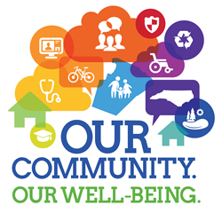
(Image credit: Wake County)

During Introduction to Community Health Project Class

Community Health Investigative Report Project (CHIRP) Introduction
You will receive your topics, group assignment, and meet. The group will:
- Determine the roles among the group members, set up a communication plan and establish meeting dates. Some group roles that may need to be assigned are:
  - Facilitator- keeps the meetings on track, on time, scheduled and focused.
  - Reporter/Scribe- takes meeting minutes, updates group members and acts as liaison to faculty advisor regarding progress.
  - Supplies Coordinator- keeps track of any supplies needed for presentation.
  - Researcher-reviews article submission for proper APA format and compiles reference list.
  - Media/technology manager-compiles, organizes, and edits videos, slide presentations, and/or other media to be used for the presentation with help and input from all group members.
- Discuss the relationship between the demographics of Deschutes County overall and the people affected by your health topic.
- What are some of the issues nurses should consider across the lifespan of the people affected directly and indirectly by the health issue being researched? What are other factors that affect this health issue? (i.e., access, cost, available resources)

Independent Group Planning Meetings

- Suggestions for Meetings
  - Establish leadership and an agenda for each meeting.
  - Suggest future agenda topics and schedule meeting dates and times.
  - Share articles from individual summaries.
  - Determine the level of participation you want from attendees of the presentation. Brainstorm possible activities for the attendees?
  - Each person in the group will actively participate in the presentation. Clearly define who is presenting which part and how.
  - What do you want to accomplish with this presentation? What takeaways do you want the attendees to come away with?
  - Mock run through the presentation.
- Use the Nursing Process to complete a Community Health Assessment and define what you want to accomplish with your presentation
  - Research community health topic and determine resources and issues surrounding topic in Deschutes County. What are the nursing roles?
  - Use the nursing process, look at the big picture of how the issue affects individuals, families, caregivers, and the community.
  - Who in the community would you like to make aware of these issues and what recommendations would you make to help with health promotion and facilitate positive changes? (colleagues, clinicians, politicians, media, businesses, etc. - also known as stakeholders)
  - What do you want attendees to learn about this topic and how it affects the community? What do you want the attendees to do?
  - Determine your outcome and objectives for your health topic:
    - Articulate an outcome statement concerning what you want to achieve with your presentation. (The What?)
    - Create learning objectives (3-5) that include knowledge, or ideas for action gained from your presentation related to achieving the outcome. (The How?)
- Project Development using SBAR to Organize for Presentation
  - Literature Review: Each individual student will find an article in the professional healthcare/nursing literature, or health professions resource on the Internet that is a resource for your health topic. No two group members may choose the same article. A 1–2-page article summary will be written. The articles/resources must be used in the development of your CHIRP presentation. Reference Purdue OWL for formatting this paper. https://owl.purdue.edu/owl/research_and_citation/apa_style/apa_formatting_and_style_guide/general_format.html
  - Reference List: Develop a reference list in APA format of all resources used to prepare for the activity including those used for individual student article summaries.
  - Presentation: Design a presentation that incorporates a variety of teaching methods such as:
    - Reading
    - Visual
    - Listening
    - Hands-on
  - Action Plan: Create a professional presentation directed to colleagues, collaborators, stakeholders, and community partners identifying the Situation, giving Background information, Assessment of issues and resources, patient experiences, patient needs, and nursing roles, then make suggestions for improving the community’s health: Recommendations.
  - Portfolio: See step 5 for a description of what to include.

Guidelines for Writing a Literature Review

Each student must submit a 1-2-page, typed summary of a professional healthcare/nursing journal article or a health professions internet resource.
- Duplicate articles will not be used in the group.
- The article/resource must be applicable to the health investigation.
- The article resource must be from a professional, peer-reviewed journal or professional health resource on the internet and must be published within the past 5 years.
Writing and Literature Review:
- Read the entire article/resource. When summarizing another’s work, get a complete picture before writing a word.
- Re-read and highlight the essential information. Focus on the thesis and topic sentences.
  - Using the highlighted information, summarize the article in your own words.
  - Then describe how this article applies to your Community Health Investigative Report Project presentation and discuss information from the article that you will use in your CHIRP presentation.
- Review your summary for completeness, conciseness, accuracy, and clarity of information presented.
- Keep the length of your summary including the description of how it applies to 1-2 pages double spaced.
- Turn in your summary and a copy of your article to your CHIRP Faculty Advisor.
- Each submission must include a Title Page and Reference Page. Follow APA format. See Writing Standards and Resources on Canvas.

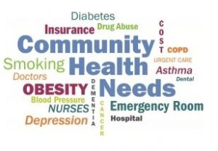
(Image credit: Southwest Health System)

Community Health Investigative Report Presentation & Portfolio

Presentation

Day of Community Health Investigative Report Presentation
- Carry out a plan for setting up and taking down your presentation.
- Clear communication of issues
- Participate as a group throughout the presentation.
- Turn in your Peer Evaluations with your other paperwork.

Turn in Portfolio

The following must be turned in to your CHIRP Faculty Advisor on the day of your group’s Community Health Investigative Research Project Presentation:
(Please place it in a folder or binder)
- Title page to include:
  - Presentation topic
  - Names of group members
  - Name of Faculty Advisor.
- Summary of the community assessments and discussion of how the health topic’s needs were assessed and determined through research, windshield survey, interviews, etc.
- Stated outcome and learning objectives of your health topic presentation.
- Presentation plan including:
  - Content and methods used to present findings.
  - Presentation materials used.
  - Equipment and supplies used.
  - Suggested publicity tools and/or activities.
  - Who is the audience? Who are people that you would like to inform?
- Completed small group and presentation evaluation tools.
- Reference list in APA format of all resources used, including the individual article summaries.
- Behind reference list include notes taken during interviews and windshield survey.

Please note: An unexcused absence from the Community Health Investigative Report Project Presentation will result in the individual student receiving 0 points for the project.

