Syllabus
Course Title: Rhetoric and Critical Thinking II
Course Number and CRN: WR65 CRN 44645
Credits: 4
Course Date: Fall 2021-2022 September 20 – December 13, 2021
Course Meeting Times: Tues/Thurs 12:45 PM – 02:35 PM
Course Location: REMOTE

Instructor: K. Donovan kdonovan@cocc.edu Office: Ochoco 119
Office Hours: Tuesdays & Thursdays 10:30 – 11:30
Tuesdays Online: 12:00-12:30 pm or by appt.
Phone: (541) 383-7701 ext.: 2035 (Please leave a message)

WR 65 – Rhetoric and Critical Thinking II - WR 65 focuses on rhetorical reading, thinking, and writing as a means of inquiry. Students will develop understanding and basic fluency with key rhetorical concepts, such as audience and purpose. They will also reflect on their reading and writing process and develop metacognitive awareness. Students will demonstrate understanding of MLA conventions for format and citations. Students will produce at least 2,000 words of revised, final draft copy, including at least one thesis-driven, minimum 1,000-word academic essay. Recommended preparation: successful completion of WR 60 or placement test scores that place the student in WR 65. Credits: 4 Lecture 4

WR 65 Course Learning Outcomes (shared by all WR 65 classes at COCC)

Rhetorical Awareness
- Analyze and compare the role of voice, audience, purpose, and point of view in a variety of texts in different disciplines.

Critical Thinking, Reading, and Writing
- Critically read, analyze, and evaluate a variety of college-level texts.
- Apply a range of reading comprehension and retention strategies for college-level texts that represent varied contexts and purposes.
- Select and evaluate sources that are appropriate for academic writing and research

Processes
- Demonstrate reading process strategies that facilitate comprehension, analysis, and retention.
- Construct original writing that demonstrates the use of process-based approaches to writing, including pre-writing, drafting, peer-reviewing, revising, polishing, and publishing text.
- Collaborate in the exchange of writing as both reviewer and author, generating and evaluating feedback as part of the revision process.

Knowledge of Conventions
- Identify English language conventions to daily and academic writing that are appropriate for the writing situation.

Metacognition and Transfer
- Explain and demonstrate how reading and writing strategies and processes apply to personal, professional, and academic goals.
Course Outline or what this course is all about, and how I will assess what you are learning as you:
- Apply the writing process to your work
- Apply practical critical reading comprehension approaches to a variety of texts
- Enhance retention of information learned by practicing supportive study strategies
- Construct an original expository essay applying effective rhetorical strategies for delivery
- Select and evaluate credible sources
- Synthesize information into a collection of thematic sources
- Construct an actual thematic unit

This course has no significant tests; instead, your work will show me what I need to know to determine your learning and ability to apply the knowledge to your work.

Primary Assignments:
Assignment | Points | Total | DUE
100 Dictionary Words (vocabulary acquisition) | 01 each | 100 points | WK 05 - 07
10 - Weekly Reflection Journals (in class) | 20 each | 200 points | WK 01 - 10
A topical, thesis-driven, expository essay, which incorporates at least three credible sources and achieves at least 1200 words in length |  | 90 points | WK 07
Process work (invention, outline, draft, peer review) | combined | 50 points | WK 02 - 06
Thematic Unit Summaries and Links
Researched Thematic Unit with 5-8 credible sources |  | 120 points | WK 09
Process work | combined | 60 points | WK 07- 08
One Reflective Essay that is at least three-and-one-half pages in length and covers the outcomes listed on page 01 of your syllabus |  | 60 points | FINALS WK
Process work | combined | 20 points | WK 09 - 10
Total for Primary Assignments |  | 600 points

In addition to the assignments listed, successful completion includes your ability to participate in group discussions, respond to readings with brief question/answer sessions, and produce process work that will accompany your writing. Impromptu check-ins, surveys, and quizzes that vary are also a possible part of the course.

Course Schedule Outline for WR65
Our weekly schedule will include activities that help build the skills you need to accomplish the tasks required to complete this class successfully.

Week 01 Focus – Getting Familiar
Tour of Canvas – Where is everything?
Going over the syllabus
Classroom introductions
Attachments in email
MLA template (phase one)

Week 02 Focus – Active Reading, Note-taking, and Annotating.
SQ3R method
Cornell Notes (adaptation)
MLA template (phase two)
Writing Center Visit
Thematic Unit “Introduction” and “Essential Questions”

Week 03 Focus – The Writing Process: Invention
Basic Essay structure
Create an MLA template
MLA Works Cited: The basics of formatting.
OWL@Purdue
Annotate a pdf.
Writing Process: Invention
Brainstorming, mind-mapping, freewriting, and word association

Week 04 Focus – The Writing Process: Outlines and Thesis Statements
Thematic Unit Readings and Discussion
Thesis statements
Outline expository essay
DUE: Outline of expository essay

Week 05 Focus – Thesis Statements – Developing a Draft from an Outline
Thesis statement’s structure and purpose
Developing a draft from an outline
Peer review expository essay

Week 06 Focus – “Build Your Own” Thematic Unit & Summarizing Sources
Summaries
- Key information
- Paraphrasing
- Citing Sources
Thematic Unit Readings and Discussion
- TU 02 Essential Questions
- TU 02 Key Terms
DUE: Final version of your Expository Essay
DUE: Summaries and Links check-in

Week 07 Focus – TU – Essential Questions & Pre-reading Activity
Review, Edit, and Publish (expository essay)
Thematic Unit Readings and Discussion
DUE: Summaries and Links

Week 08 Focus – Structure and Synthesis
Thematic Unit Readings and Discussion
Writing Workshop

Week 09 Focus – Reflective Essay – Outline & Revision
Thematic Unit - Finalizing
Reflective Essay Outline

Week 10 Focus – Reflective Essay Workshop
Peer Review
Revision Workshop
DUE: Thematic Unit

Week 11 Focus – Reflection on a Term
Finals Week

Instructional Methods
We will be working individually and together to improve reading, writing, and editing skills in this class. Classes will include lectures, exercises, discussions, workshops, peer reviews, and substantial reading and writing homework. Your full participation in this class will help you and your classmates reach the outcomes for this course. Participation is mandatory.

This course uses a “Writing Across the Disciplines” approach, which requires reading and writing assignments from literature, social science, and scientific articles, in addition to podcasts, YouTube video content, and other multimedia sources.

Thematic Units are part of learning to develop critical reading and writing approaches to various texts, both as readers and writers. A thematic unit is a collection of sources and information centered on a specific topic or theme. We will be working with thematic units.

Textbook & Materials
Course Texts  (Required) | A collegiate dictionary Merriam-Webster’s or Oxford English Dictionary – online or print  The online version of the Reading Writer’s textbook on Canvas may also be requested in print at the bookstore for a fee.
Course Texts  (Optional) | Bullock, Richard, et al., The Little Seagull, 3rd ed. (Norton) with exercises  ISBN-13: 978-0393602630 (required in WR121)
Course  Materials  (Required) | - Highlighters – at least two colors (for annotating articles)  - Access to a computer, Internet, and Microsoft Word for assignments  - Access to your One Drive for storing documents  - Access to Blackboard for interaction and assignments  - Access to Zoom for office hours and remote class
Course  Materials  (Optional) | - Flash drive or another device to save computer work

Technology: This course is delivered online in Zoom with support materials on Canvas.
Technology Assistance: Contact Student Technical Support: 541-383-7716. Access self-help resources online <https://www.cocc.edu/departments/elearning/student-online-resources/default.aspx>. Visit a computer lab in Bend-Boyle Education Center or Pioneer Hall; Redmond-Redmond Technology Center; Madras; Prineville.

What do I expect from you?:
I expect you to show up to class on time, prepared to engage in the classroom activities. The reading required is done outside of the classroom, but the information helps you understand what we discuss in the classroom – that means reading on your own.

What can you expect from me?:
Like you, I have to show up on time and prepare for classroom activities. Reading to prepare for class is done outside of class to present and be ready for your questions in class. You can expect me to respond to your email within twenty-four hours Monday through Friday (usually, it is much quicker).

Class Time and Attendance
Class and attendance: All of your work in this course will help you complete the course-level outcomes listed on the first page of the syllabus, which means you will have learned what is required to pass this class. Most of the materials needed to complete this course successfully are on Canvas. However, additional information shared for assignments in-class may expand on more significant tasks through discussion and activities only done in class. The bottom line is that class time is essential and regular, timely attendance is mandatory.

If you miss a class, please don’t ask me to tell you what you missed while you were gone. I do not repeat class lectures individually (can you imagine the time that might take?); instead, consider exchanging phone numbers or email addresses with at least one classmate for contact. This person can fill you in on what you may have missed, and you can do that for them. You might even find someone you can study with too! Of course, you are still responsible for turning in any assignments due on time.

Please let me know by email if you know you will be gone ahead of time to discuss arrangements for your work. If you talk to me ahead of time, the chances are good that we can come to an agreement that works for both of us. Communication is

When you contact me, please put the CRN in the subject line, followed by a dash, your name, another dash, and why you are writing. It should look something like this:

44645-Sunny Day-Question about the reading

Late Work: There are exceptions to all rules, and reasonable requests to turn work in late are one of them, but the time frame for the course work is carefully designed to allow each learner to get the project done and get the feedback, so they know how best to proceed. Assignments need to be turned in on time to provide feedback promptly for the best results.

As a general rule, late work will be accepted for only TWO class periods for essay drafts and may not receive written comments. I will grade late assignments as soon as I am able. The works turned in on time receive priority. In-class assignments must be completed and turned in by the end of the assigned class period (including peer review drafts).

Extra Credit: There is not generally extra credit work given in this class, but I can be encouraged by creative ideas delivered in writing. If you have an idea for an assignment, turn it in in writing. If the assignment is accepted as something that the whole class can do and adds value to the lessons, the creator will receive points, and anyone who does the additional assignment will receive extra credit.

Courtesy: “polite behavior that shows respect for other people” (Merriam-Webster)

Writing Task Submissions

General Writing Assignments: All writing tasks must be submitted using Modern Language Association (MLA) format - typed, double-spaced, using 12-point. Times New Roman font. Use your handbook (if you have one) to correctly document your written assignments, or visit the OWL@Purdue website to cite your sources appropriately. If you are not familiar with MLA now, you will be before the end of the term.

Expository Essay: You will work through the writing process, from the invention portion, through the final draft of an essay written in the third person. The expository essay’s purpose is to explain or inform your audience about a topic as the authority, using sources provided to back you up.

Build-Your-Own Thematic Unit: Critical thinking, reading, and writing skills used in building your Thematic Unit will provide an opportunity for you to gain overall comprehension of an approved topic. As you create your Thematic Unit, you will also better understand your audience through peer review collaboration and group communication. You will evaluate several sources, then choose and include five to eight credible sources of varying types and perspectives on the selected topic. The purpose is to provide your audience with a non-biased, informative presentation accurately cited using MLA guidelines.

Reflective Essay: This is a collection of your efforts for the term, in a three-and-one-half paged essay, based on the outcomes for this course and written in the first person. The Weekly Reflections collect information that you will use in this final paper. The more detailed your original input is, the easier it will be to put your Reflective Essay together at the end of the term.

Peer Review Drafts: You will share a complete draft of all the major writing tasks before the final draft is due. Classmates will read your typed drafts and give you a chance to make corrections before you turn in the final draft. There is no make-up for missing peer review sessions. If you miss peer review sessions, you miss crucial skills required to complete this course.

Submitting Assignments: We will use Canvas’ dropbox for most assignments.

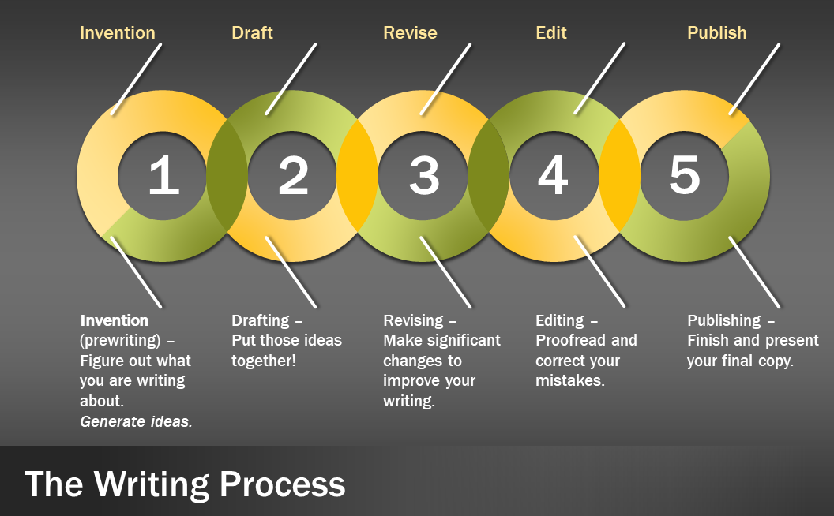
Calculation of Course Letter Grade
A – 90-100  B – 80-89  C – 70-79  Anything C or above passes!  D – 69 – 60 or below is Np |  | Writing 65 is a Pass/No Pass class. What that means for you is that anything C or above means you are passing this class.  Anything D or below is a No Pass.  The letter grades only let you see where you are as you complete the assignments.

Conduct and Behavior: COCC College personnel expect all students to behave appropriately in the college classroom. This requirement means that one must always respect classmates and one’s instructor. Any disruptive behavior in the classroom may result in suspension or removal from the course.

Netiquette
- Respect other’s privacy  - Respect other’s opinions  - Back up your opinions with facts  - Treat other’s how you want to be treated  - This is a classroom, and your behavior should reflect that  - Spellcheck before posting  - Use emoticons and acronyms sparingly | - ALL CAPS IS SHOUTING  - Use caution with humor and sarcasm to avoid misunderstanding  - The private conversation has no place in a public post  - Words live online forever; use care when posting

COCC Academic Calendar
https://www.cocc.edu/departments/admissions/degrees-and-classes/academic-calendar-and-exam-schedule.aspx

Final Exam Policy & Final Exam Schedule
All classes at Central Oregon Community College include some kind of graded or evaluated activity during the period set aside and scheduled for final examinations. On an individual basis, for emergencies and other special circumstances, a student may take a final examination at a time other than that scheduled, providing the student has received prior approval by petition signed by the instructor and the department chair. Approved petitions are returned to instructors, with copies sent to the Vice President for Instruction. These arrangements are rare and must be made early in the term. Information about the final exam schedule, policies for rescheduling final exams, and final exam policies are located on the Academic Calendar web site.

Final Exam Schedule https://www.cocc.edu/departments/admissions/degrees-and-classes/files/academic-calendar-and-exam-schedule-21-22.pdf
The following deadlines apply to full term courses; for part-of-term courses, see individual dates.

COCC Enrollment Deadlines
The first week of each term | Mandatory attendance: students not in attendance or absent with instructor permission are administratively withdrawn
5 pm, Friday of the second week | Last day to drop with a full refund.
5 pm Friday of the seventh week | Last day to drop with no grade on transcript, last day to change to an audit, instructor approval not required
6 pm, Wed. of the tenth week | Last day to drop, requires instructor approval, shows as “W” on the transcript
https://www.cocc.edu/departments/admissions/degrees-and-classes/academic-calendar-important-dates-by-term.aspx

Americans with Disabilities Statement
Students with documented disabilities who may need accommodations, who have any emergency medical information the instructor should know of, or who need special arrangements in the event of evacuation, are encouraged to make an appointment with the instructor as early as possible, no later than the first week of the term. Students may also wish to contact the COCC Disability Services Office in the Barber Library, 541 383-7583.

Non-Discrimination Policy
The goal of Central Oregon Community College is to provide an atmosphere that encourages our faculty, staff and students to realize their full potential. In support of this goal, it is the policy of the Central Oregon Community College that there will be no discrimination or harassment on the basis of age, disability, sex, marital status, national origin, ethnicity, color, race, religion, sexual orientation, genetic information, veteran status or any other classes protected under Federal and State statues in any education program, activities or employment. Persons having questions about equal opportunity and non-discrimination may contact Human Resources for referral to the appropriate personnel, 541-383-7236.

Student Rights and Responsibilities
Please read the Student Rights and Responsibilities Handbook.

Title IX Statement: Title IX protects people from discrimination based on sex in education programs and activities. This includes conduct such as: gender discrimination (includes males, females, transgender, gender identity, etc.), sexual harassment, sexual assault, stalking, intimate partner/relationship violence, bullying and cyberbullying, retaliation, the failure to provide equal opportunity in athletics and discrimination based on pregnancy. Persons having questions about Title IX should Alicia Moore, Title IX Officer, 541-383-7244, amoore@cocc.edu. For more information on COCC’s Title IX policy, see: https://www.cocc.edu/departments/human-resources/employment/equal-opportunity/title-ix-information.aspx

Safe Zones at COCC
Safe Zones are confidential and safe environments for lesbian, gay, bisexual, transgender, and queer (LGBTQ) individuals. The Safe Zone symbol displayed around the campus identifies individuals who are compassionate, understanding, and committed to helping create an open and accepting environments for all on the COCC and OSU-Cascades campuses. Safe Zone volunteers can be identified on campus by the Safe Zone logo posted on or near an office door. For more information and a list of volunteers, see the Safe Zone web page at https://www.cocc.edu/departments/multicultural/lgbtq-programs/safe-zone-training.aspx

Veterans and Student Service Members
Veterans and active-duty military personnel with special circumstances (e.g., upcoming deployments, drill requirements, disabilities) are welcome and encouraged to communicate these, in advance, if possible, to the instructor.

Housing and Food Insecurity
Any student who has difficulty affording groceries or accessing sufficient food to eat every day, or who lacks a safe and stable place to live and believes this may affect their performance in the course, is urged to contact Central Oregon 211 for support. Furthermore, please notify the instructor if you are comfortable in doing so. This will enable him/her to provide any resources that he/she may possess.

Student Insurance
Students are not covered by medical insurance while on campus or involved in college classes and activities. Students are responsible for their own medical and dental insurance coverage.

Counseling Services
Feeling a little bit stressed or discouraged? Personal issues distracting you from your learning? COCC contracts with St. Charles Hospital to provide free, confidential, personal counseling on the Bend campus for any student who needs it. These sessions are with licensed, professional counselors. Call CAP Services to make an appointment 541-383-7200.

Principles of Community
The students, faculty, staff, and administrators at COCC comprise a Community of Learners. This community supports one another by practicing personal and academic integrity, respecting the dignity of all persons, promoting empathy and understanding, respecting the rights and property of others, and promoting a healthy and safe learning environment. By collectively living these principles, we create the greatest opportunity for personal and academic excellence. For more information, please visit https://www.cocc.edu/departments/multicultural/creating-community.aspx

Cheating/Plagiarism
An essential part of your work in this class will be reading, synthesizing, using, and responding to the ideas of others. Plagiarizing uses those ideas (or words) without acknowledging that they originated from someone or somewhere else. Therefore, all material written for this class must be original (you wrote), especially for this course (no recycling papers). As you know, becoming better at a skill means you need to exercise, and writing is no different—good writers are made, not born!

Plagiarism Statement
Proper citations and documentation of any sources that you quote, paraphrase, and/or summarize in your writing are required whenever you borrow the words, facts, and/or ideas of others. To avoid plagiarism, you must cite any source you use in your writing: (1) at the point in your project where the borrowing occurs (parenthetical citations for most academic documentation systems), (2) in a list of all sources cited given at the end of a project.

Plagiarism - intended or not, is a serious academic violation of intellectual property rights and will earn your written assignment an automatic ‘F’. The second instance of cheating or plagiarism will result in a removal from the class.

Types of plagiarism: | From turnitin.com
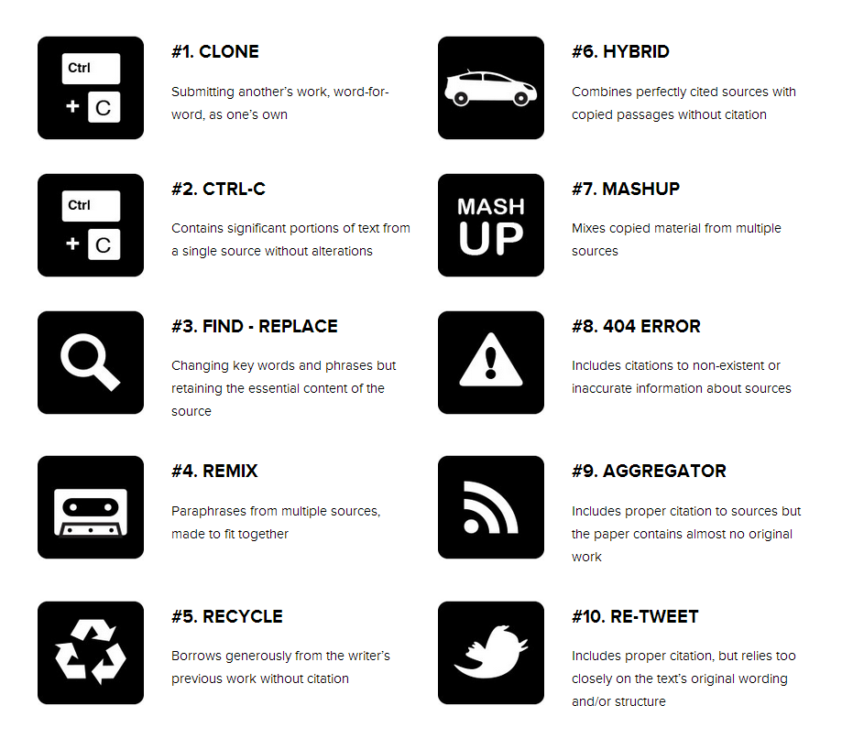 |  | For more information on plagiarism: https://www.plagiarism.org/understanding-plagiarism  For more information on COCC’s policy on academic honesty here:  https://www.cocc.edu/policies/general-procedures-manual/student/student-rights-and-responsibilities.aspx

Finals Week is December 6 – 10
Your final is Tuesday, 07 December 2021
01:00 PM – 03:00 PM

Arrive on time – late arrivals will not be allowed to take the final.

