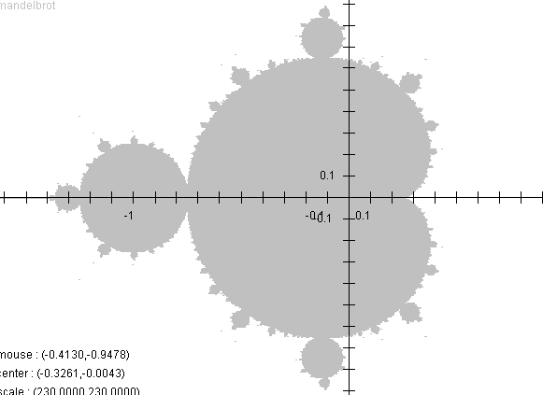
Mandelbrot for the Masses Iteration Formula: ${\text{z} }_{n+1}={\left({z }_{n}\right)}^{2}+c$

Try:$1=c={z }_{1}$ $c=-1$ $c=-2$ Calculator tips for generating the sequence:
$${\text{z} }_{2}={\left({z }_{1}\right)}^{2}+c$$  $$2={\left(1\right)}^{2}+1$$ | $$0={\left(-1\right)}^{2}+(-1)$$ |  | 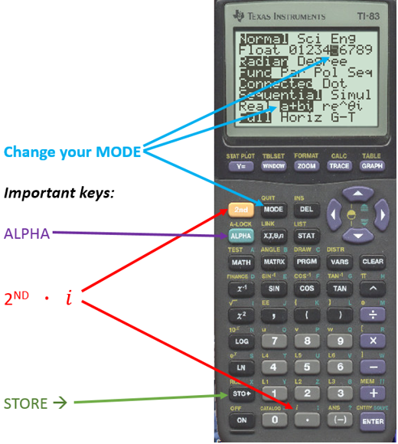  Note 2nd MODE (QUIT) will get  you back to the Home Screen  Anything in a BOX is a key stroke.  (Use the Arrow Keys)  - For practice, type in -2  (-) 2 STO> ALPHA PRGM (C) ENTER (This is z₁)  2nd (-) (ANS) x² + ALPHA PRGM (C) ENTER (This is z₂)  ENTER (This is z₃)  ENTER (This is z₄) … etc.
$${\text{z} }_{3}={\left({z }_{2}\right)}^{2}+c$$  $$5={\left(2\right)}^{2}+1$$ | $$-1={\left(0\right)}^{2}+(-1)$$
$${\text{z} }_{4}={\left({z }_{3}\right)}^{2}+c$$  $$26={\left(5\right)}^{2}+1$$ | $$0={\left(-1\right)}^{2}+(-1)$$
$${\text{z} }_{5}={\left({z }_{4}\right)}^{2}+c$$  $$677={\left(26\right)}^{2}+1$$ | $$-1={\left(0\right)}^{2}+(-1)$$
$${\text{z} }_{6}={\left({z }_{5}\right)}^{2}+c$$  $${\left(677\right)}^{2}+1$$  $$=458,330$$ | $$0={\left(-1\right)}^{2}+(-1)$$
$$\left|z\right|=\left|a+bi\right|$$  $=\sqrt{a^{2}+b^{2}}$  $$\left|{z }_{6}\right|=458,330$$ | $$\left|{z }_{5}\right|=1$$  $$\left|{z }_{6}\right|=0$$ | $$\left|{z }_{6}\right|=$$

IF you’re feeling adventurous, try the next few suggestions and use your calculator to find the values:

Try: $c=0.2$ $c=0.3$ $c=i$ $c=\frac{1}{2}i$ $c=0.2+0.2i$ , $c=0.5+0.5i$ , $c=-2.1$
$${\text{z} }_{2}={\left({z }_{1}\right)}^{2}+c$$

$${\text{z} }_{3}={\left({z }_{2}\right)}^{2}+c$$

$${\text{z} }_{4}={\left({z }_{3}\right)}^{2}+c$$

$${\text{z} }_{5}={\left({z }_{4}\right)}^{2}+c$$

$${\text{z} }_{6}={\left({z }_{5}\right)}^{2}+c$$

$$\left|z\right|=\left|a+bi\right|$$  $=\sqrt{a^{2}+b^{2}}$  $$\left|{z }_{6}\right|=$$ | $$\left|{z }_{6}\right|=$$ | $$\left|{z }_{6}\right|=$$ | $$\left|{z }_{6}\right|=$$ | $$\left|{z }_{6}\right|=$$ | $$\left|{z }_{6}\right|=$$ | $$\left|{z }_{6}\right|=$$

