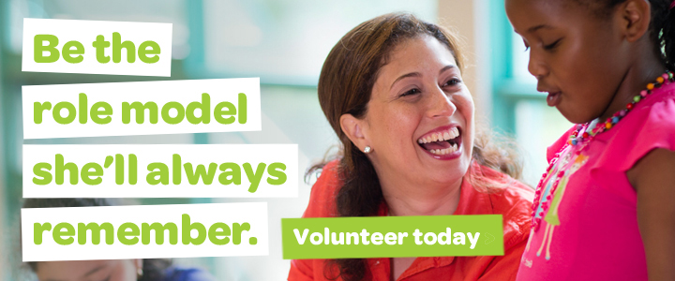

Volunteer with Girl Scouts today.
The mission of Girl Scouts is to build girls of courage, confidence, and character, who make the world a better place. This would be impossible without our volunteers: adults who give their time, energy, and passion to provide opportunities and leadership skills that enable girls to learn and grow. As a volunteer, you'll introduce girls to new experiences that show them they're capable of more than they ever imagined. You'll be their cheerleader, guide, and mentor, helping them develop skills and confidence that will last long after the meeting is over. Imagine the smiles, the excitement, the memories made--those are the moments you'll share at Girl Scouts.
Explore what being a volunteer could mean for you. We know what it means for girls.

Girl Scout volunteers can participate in a variety of ways. You can be a troop leader, co-leader or troop helper. You can join the service team, a group of volunteers in a given area who organize events and support local volunteers. You can work with a team to plan an event, offer office support, or lead a special program for girls. Whether you can give a day, a few weeks, or the whole year, it all starts with you. As a Girl Scout volunteer you will have support from staff and a network of volunteers.

Here’s how to get started.

Contact Nancy Crocker, Volunteer Support Specialist, at 541-389-8146 or ncrocker@girlscoutsosw.org or drop by our office at 908 NE 4th Street in Bend to find a volunteer role that’s a good fit for you and your schedule.

Benefits for you!
- Are you planning to become a teacher or other career working with children? This is a great way to gain the significant experience with children that you need.
- Gain real world experience that looks good to a future employer.
- Fulfill service learning or other volunteer requirements in a fun and meaningful way!

