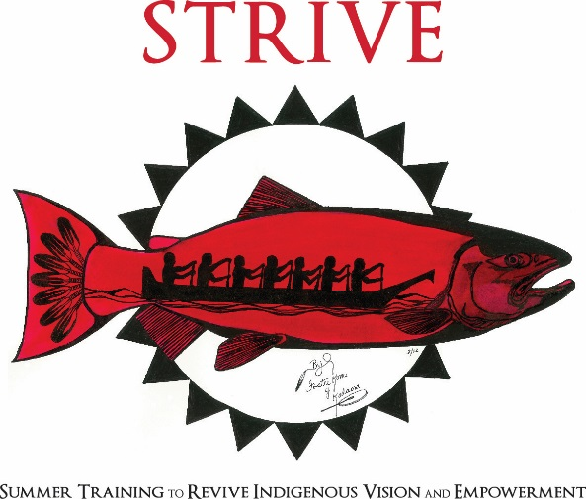

Name (First and Last):
Birthday (MM/DD/YYYY)
Mailing Address:
City: State: Zip Code
Home phone: Cell:
Personal Email:
Names and phone number of Parents/Guardians:

What is the best way to contact you? (Phone, email, parent’s phone, grandma’s phone, etc.)

Do you need transportation from Warm Spring or Madras to Bend for STRIVE?

If no, please provide the name & phone number of the person who will pick you up/drop you off:

Do you have access to internet at home?

Name of school you are attending:
Grade:
What year do you expect to graduate from high school:
What tribe(s) are you affiliated with?
T-shirt size 3XL 2XL X-large Large Medium Small

Have you been to STRIVE before?

Gender Identity and preferred pronouns:

What to you hope to gain by attending STRIVE?

What are your goals for after high school?

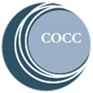
Once you complete the application, please email or mail it to:
Central Oregon Community College
Attn. Geneva Mayall
2600 NW College Way
Bend, Oregon 97701
gmayall2@cocc.edu

Applications are accepted on a first come, first serve basis

If you have any questions, please call or email Geneva Mayall,
Native American College Prep Coordinator
541-330-4369 gmayall2@cocc.edu

