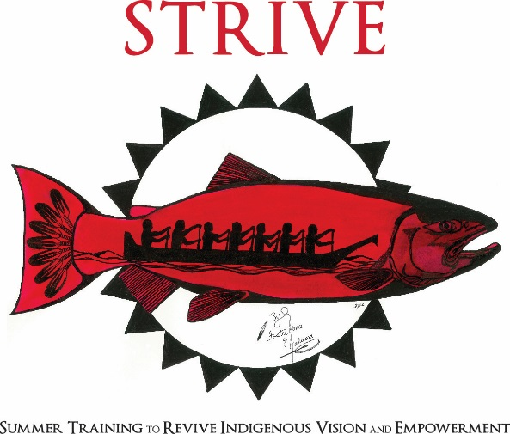

An Online, Virtual Program
Online Sessions:
Tuesdays and Thursdays 5:30-7:30pm
August 4 through August 27

Name (First and Last):
Birthday (MM/DD/YYYY)
Mailing Address:
City: State: Zip Code
Home phone: Cell:
Email:
Names and phone number of Parents/Guardians:

What is the best way to contact you? (Phone, email, parent’s phone, grandma’s phone, etc.)

Do you have access to internet?

Do you have access to a computer?

Name of school you are attending:
Current grade level in school:
Year you expect to graduate from High School:
Current GPA: ________ (this will not affect your acceptance to STRIVE)
Tribal Affiliation:
T-shirt size 3XL 2XL X-large Large Medium Small

Have you been to STRIVE before?

Gender Identity and preferred pronouns:

What to you hope to gain by attending STRIVE?

What are your goals for after high school?

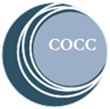
Once you complete the application, please email or mail it to:
Central Oregon Community College
Attn. Kelsey Freeman
2600 NW College Way
Bend, Oregon 97701
Kfreeman@cocc.edu

Applications are accepted on a first come, first serve basis
If you have any questions, please call or email Kelsey Freeman,
Native American College Prep Coordinator 541-330-4369 kfreeman@cocc.edu

