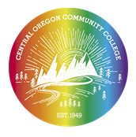
¡GANAS!
Application Form

Application Deadline: No later than May 30, 2023
Please respond to the following questions. Answer honestly and to the best of your ability, and as neatly as possible. Your personal information will be held confidentially. Program starts Tuesday, June 24 - Friday, June 27

Name (First and Last):
Birthday (MM/DD/YYYY)
Home or Mailing Address:
City: State: Zip Code
Home phone: Cell:
Email:
Languages you speak (fluently or not)
Language(s) primarily spoken in your home:
Parents/guardians who will drop you off or pick you up after program & phone number:

Name of school you are attending:
Current grade level in school:
Year you expect to graduate from High School:
Current GPA: ________ (this will not affect your acceptance into the GANAS program)
T-SHIRT SIZE X-large large medium small

Returning GANAS student: Yes No

Why do you want to attend COCC’s GANAS PROGRAM?

Please describe what your future goals are in detail?
Please discuss what things you are currently doing at your High school and/or community?
For returning GANAS student. Why do you want to return to GANAS?
Please return to Claudia Bisso-Fetzer, Ph.D. cbissofetzer@cocc.edu

