How to make a van reservation using 25Live Scheduling:
- Go to Employee Login and Click on the 'COCC Employee Intranet'
- Under the 'Employee Resources' column, click on '25Live (Web Viewer)'
- Click on 25Live Scheduling
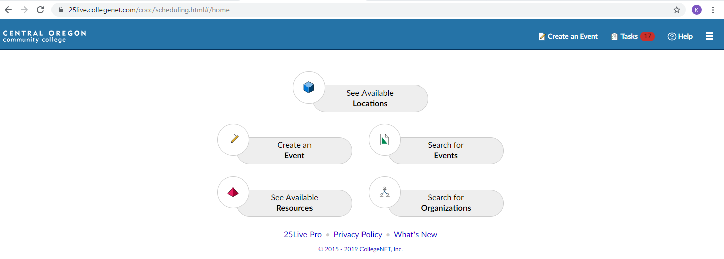
- Once you are on this page, click on the 'Create an Event' tab
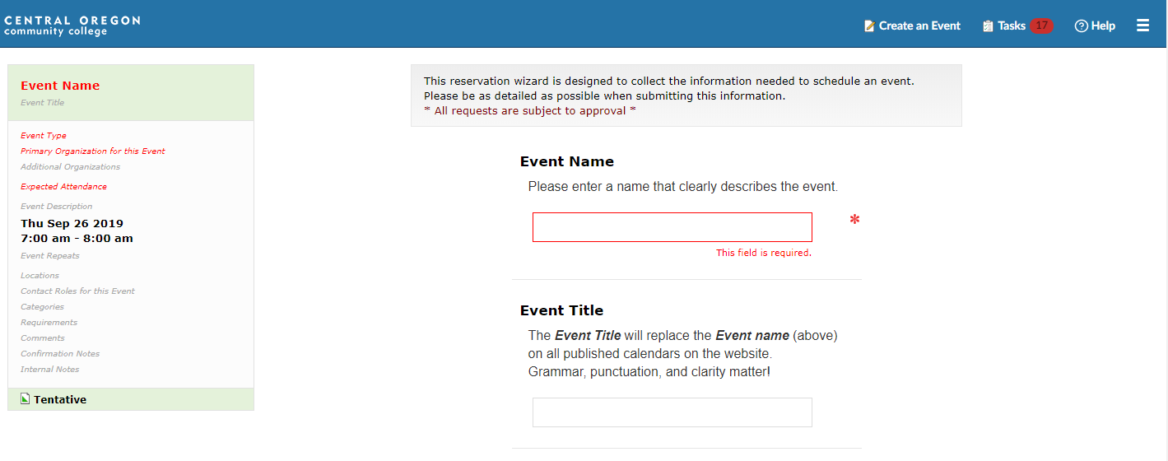
- In the 'Event Name' box, enter the name of the trip (example: FOR 248 Field Trip 1)
- In the 'Event Title' box, enter the names of the drivers.
  - I need to make sure that the driver is approved and covered by our insurance before I can send the van out
  - This is an important field, if you are unsure who the driver is going to be, please type 'Unknown'
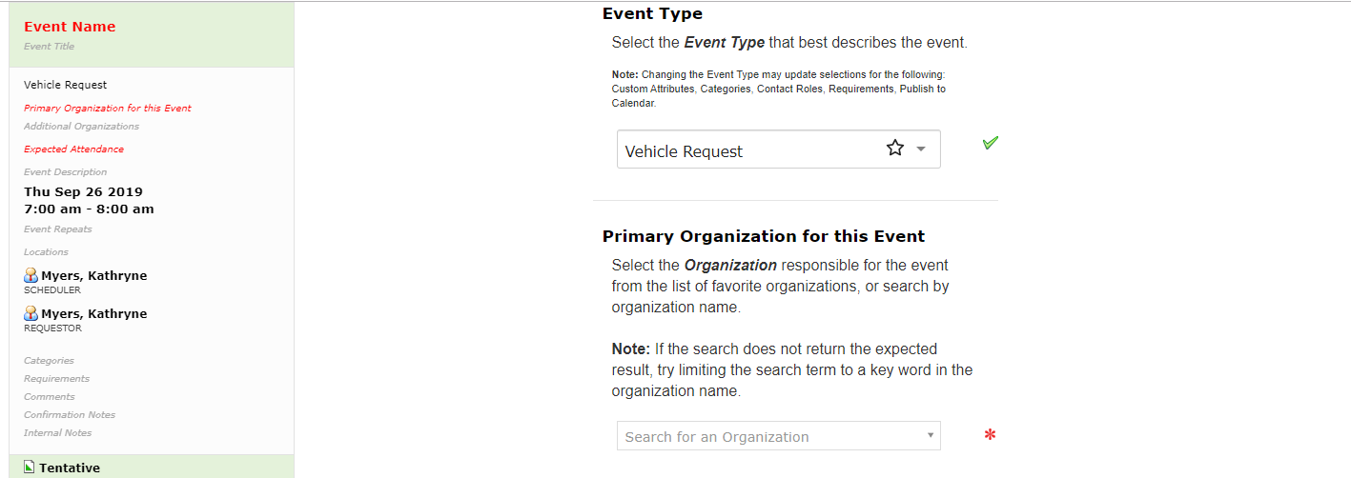
- For the 'Event Type', select 'Vehicle Request' (last option on the drop-down list)
- For the 'Primary Organization for this Event' enter your department (example: Forestry or Student Life)
- You do not need to fill in the 'Additional Organization' box
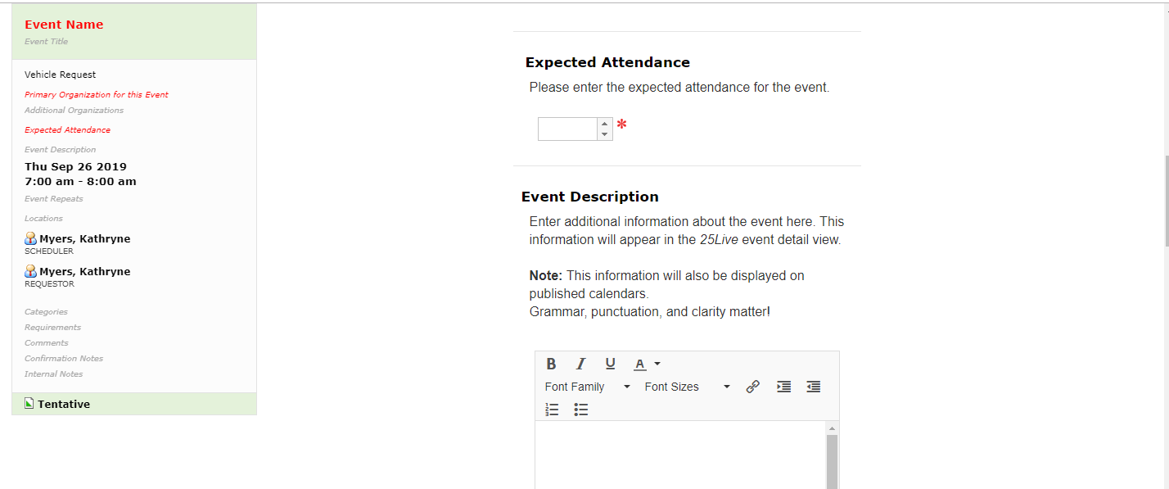
- Please enter number of people that you plan to attend the trip, including the driver, in the 'Expected Attendance' box
- Event Description is not necessary to fill in
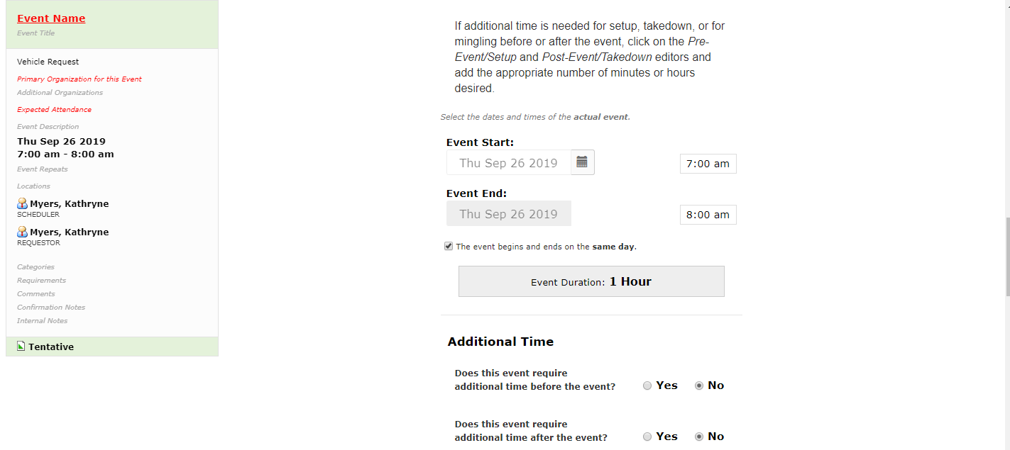
- Enter the event start and end date and time
  - If the event does not end on the same day that it starts, uncheck the box below the 'Event End:' box
  - You should not need additional time before or after the event, leave them checked as no
    - If you believe you need additional time before or after the event, please call Campus Services at 541.383.7775
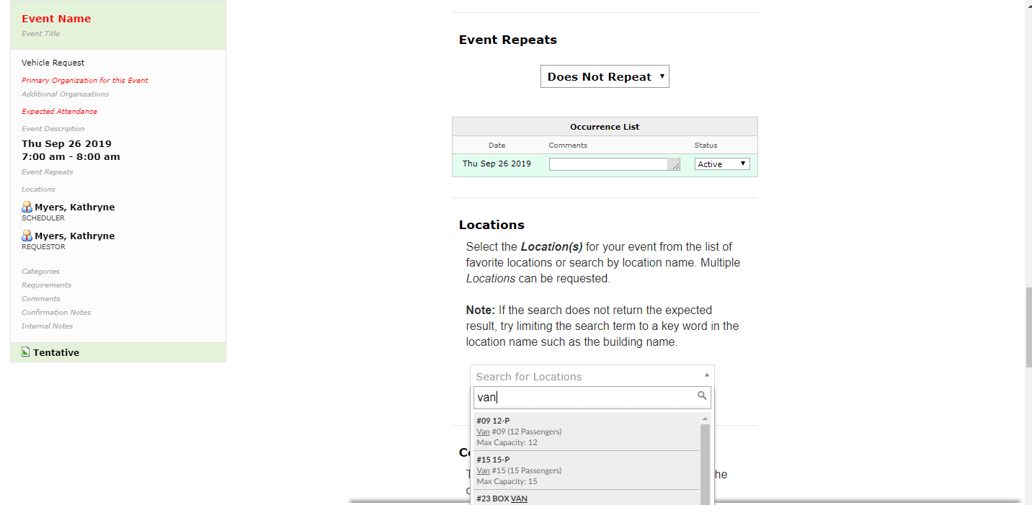
- If the event does not repeat, leave this section as is
  - If the event does repeat, select from the following:
    - Ad Hoc Repeat- meaning the days it repeats are not every Friday, or every three days, etc
    - Daily Repeat- meaning this trip will repeat daily
    - Weekly Repeat- meaning this trip will repeat every ____day, every week
    - Monthly Repeat- meaning this trip will repeat every ____ day of every month
- To search for a location, type van for a 12 or 15 passenger van or Suburban for an 8 passenger Suburban
- Select a vehicle (Note: the vehicle that you select, may not be available. If you have a reason for the selection (roof rack, tow hitch, etc.) please put that in the comments and I will do my best to accommodate
- Leave the Contact Roles for this Event as they are
- For Categories, select 'Academic Event
- The Comments section is a great section to let me know anything you are unsure about, might have questions on, or if any glitches occurred
- Click 'Save'
- I will process the requests as quickly as possible and will contact you if I have any questions or am unable to confirm the request

