Thank You for helping COCC work towards
Zero Waste!
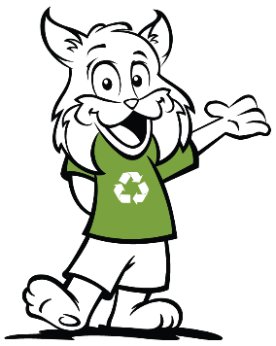
Goal:
Increase recycling, streamline collection and everyone understands how to recycle!

A good recycling program consists of:
- proper infrastructure – collection bins
- focus on education – posters and bin labels
- YOU!

What:
Many studies show that a centralized waste system works best to decrease contamination (of trash in recycling containers) and increase recycling.

Centralized means collection bins setup in hallways, lounges and common areas.

Instead of individual trash bins in each classroom, you will find waste stations in centralized areas.

Why:
Recycling and trash will always be coupled together as a complete system.

This will decrease custodial time, which means more time to clean and help us all stay healthy!

It will save time, money, and resources!

How:
Please take your trash and recycling when you leave classrooms and place in the centralized bins.

Got Feedback? Contact us!
https://www.cocc.edu/committees/sustainability

