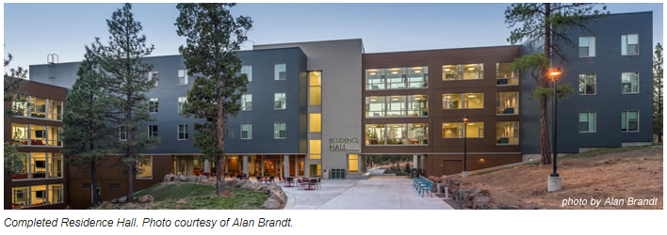
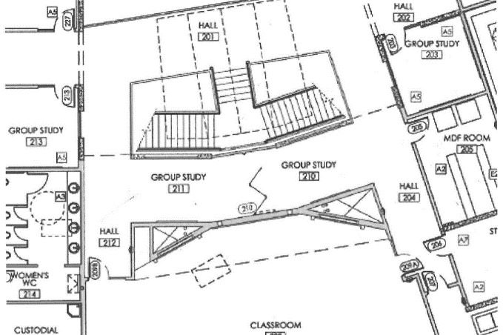

Strategic Planning and CPAT – Building Our Home
Like a Building Plan…
- Homeowner has an idea of the building they want constructed
- Go to architect to get a plan made, which starts with the floor plan
- Once floor plan is approved by the homeowner the architect compiles a set of construction documents
- General Contractor manages the plan and schedules sub-contractors to implement work to complete the house
- In order to build the house, the sub-contractors start the work of building their portion of the structure following a plan that will create the finished house according to the goal the homeowner established in their desired floor plan. To do this they each have a plan that is part of the construction documents:
  - Foundation schematic
  - Electrical schematic
  - Plumbing schematic
  - Roof
  - Finish
If each of these sub-contractors just started implementing their craft without following a plan, they might end up with a toilet where the kitchen is supposed to be, a light switch to the den in the closet and so on. By following the plan outlined by the architect, the end result will meet the vision the homeowner desires using materials they value.
In this analogy:
- COCC president is the homeowner, with input from the college “family” – Ohana
- CPAT is the architect during planning of the Strategic Plan
- Strategic Plan is the floor plan
- CPAT is also the general contractor during implementation phase
- College leadership is the supervisor or job foreman
- College leadership is the inspector of the work being done
- Various COCC departments are the sub-contractors
- Plans of the various COCC departments are the schematics of the house plan

