Open Educational Resources
for Teaching and Learning
Tina Hovekamp, Chris Rubio, Annemarie Hamlin

Useful websites for finding Open Educational Resources
http://www.cocc.edu/library/oer - COCC Library page contains numerous useful links for learning about and finding open educational resources
http://open.umn.edu/opentextbooks - The Open Textbook Library is a collection of textbooks that have been funded, published, and licensed to be freely used, adapted, and distributed.
https://www.openstaxcollege.org/books - The OpenStax College website contains several ready-to-use open textbooks, primarily in the sciences and social sciences.
http://open.bccampus.ca/find-open-textbooks/ - The BC Open Textbook Project created a collection of open textbooks aligned with the top 40 highest-enrolled subject areas in BC.
https://www.oercommons.org – The OER Commons is a digital library for finding OER for textbooks and teaching.
http://www.merlot.org – Multimedia Educational Resource for Learning and Online Teaching is a collection of free and open online resources for teaching and learning.
Grant information
http://openoregon.org/call-for-proposals-open-educational-resources-grants/
Open Oregon seeks grant proposals that implement high-impact, collaborative projects in support of open education and reduced textbook costs for students. Grant funding of $200,000 is made available by the Oregon Community College Distance Learning Association. Proposals are invited in four categories:
- Adopt – Redesign your course to incorporate an existing open textbook or open course content as is.
- Revise/Remix – Remix existing open educational resources and create new open content to bridge gaps in available resources to enable a fully open course.
- Author – Create a substantially new open textbook or open course where it is possible to demonstrate that quality resources are not currently available to meet learning objectives.
- Other – Propose a different kind of project not covered by the three categories above.

Creative Commons licensing symbols
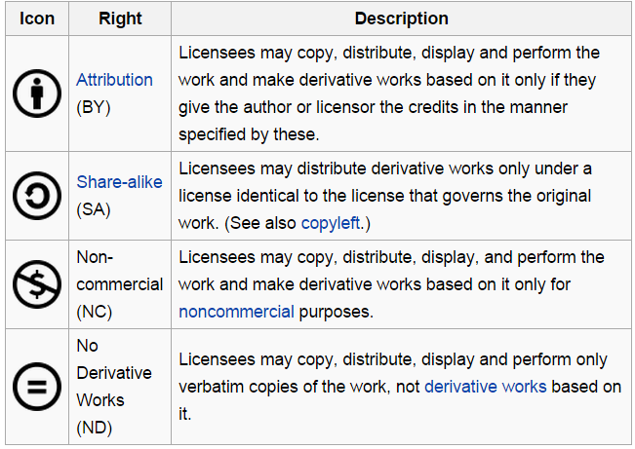

Image credits (used under creative commons license and available below):
Computer image: A conceptual image. Photography. Encyclopædia Britannica ImageQuest. Web. 21 Jan 2016.
http://quest.eb.com/search/115_3970994/1/115_3970994/cite
CC licensing symbols: http://creativecommons.org/

