Scheduling Regular Office Hours

Scheduling a Recurring Meeting
Sign in to https://zoom.us or launch the widget from your taskbar.
Click ‘Schedule a Meeting’ or click the Schedule icon on the widget.
In the Topic field, give your meeting a descriptive name, i.e.: [Your Name] Friday Office Hours, and a description if you wish. Choose your time and date. Check the box for the option to make the meeting Recurring.
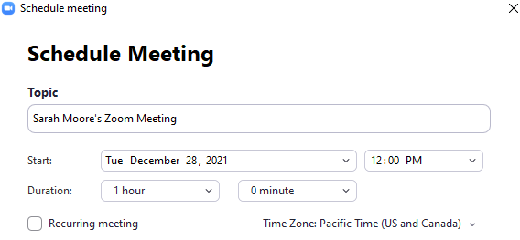
Note: Recurring meetings will retain the same meeting ID/ entry URL for 365 days past its last use. Non-recurring meeting IDs are good for 30 days. Click Save.

Add the Meeting to a Canvas Course
In the next screen, look for the Meeting ID and Invite Link. Copy this link. In Modules, click the plus button in a module header and add an External URL. Paste this link into the URL field. Name the link, and click Add Item.
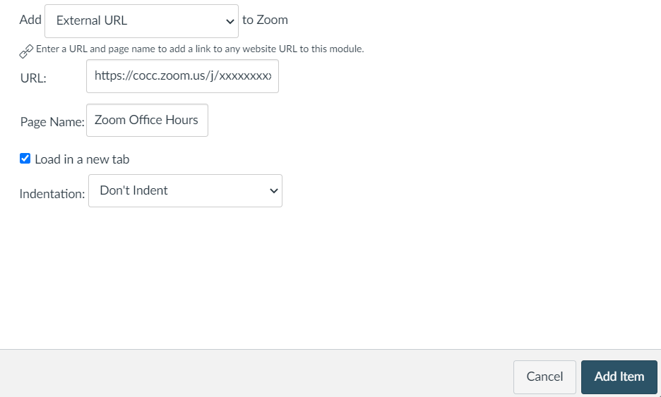
xxxxxxxxxx

